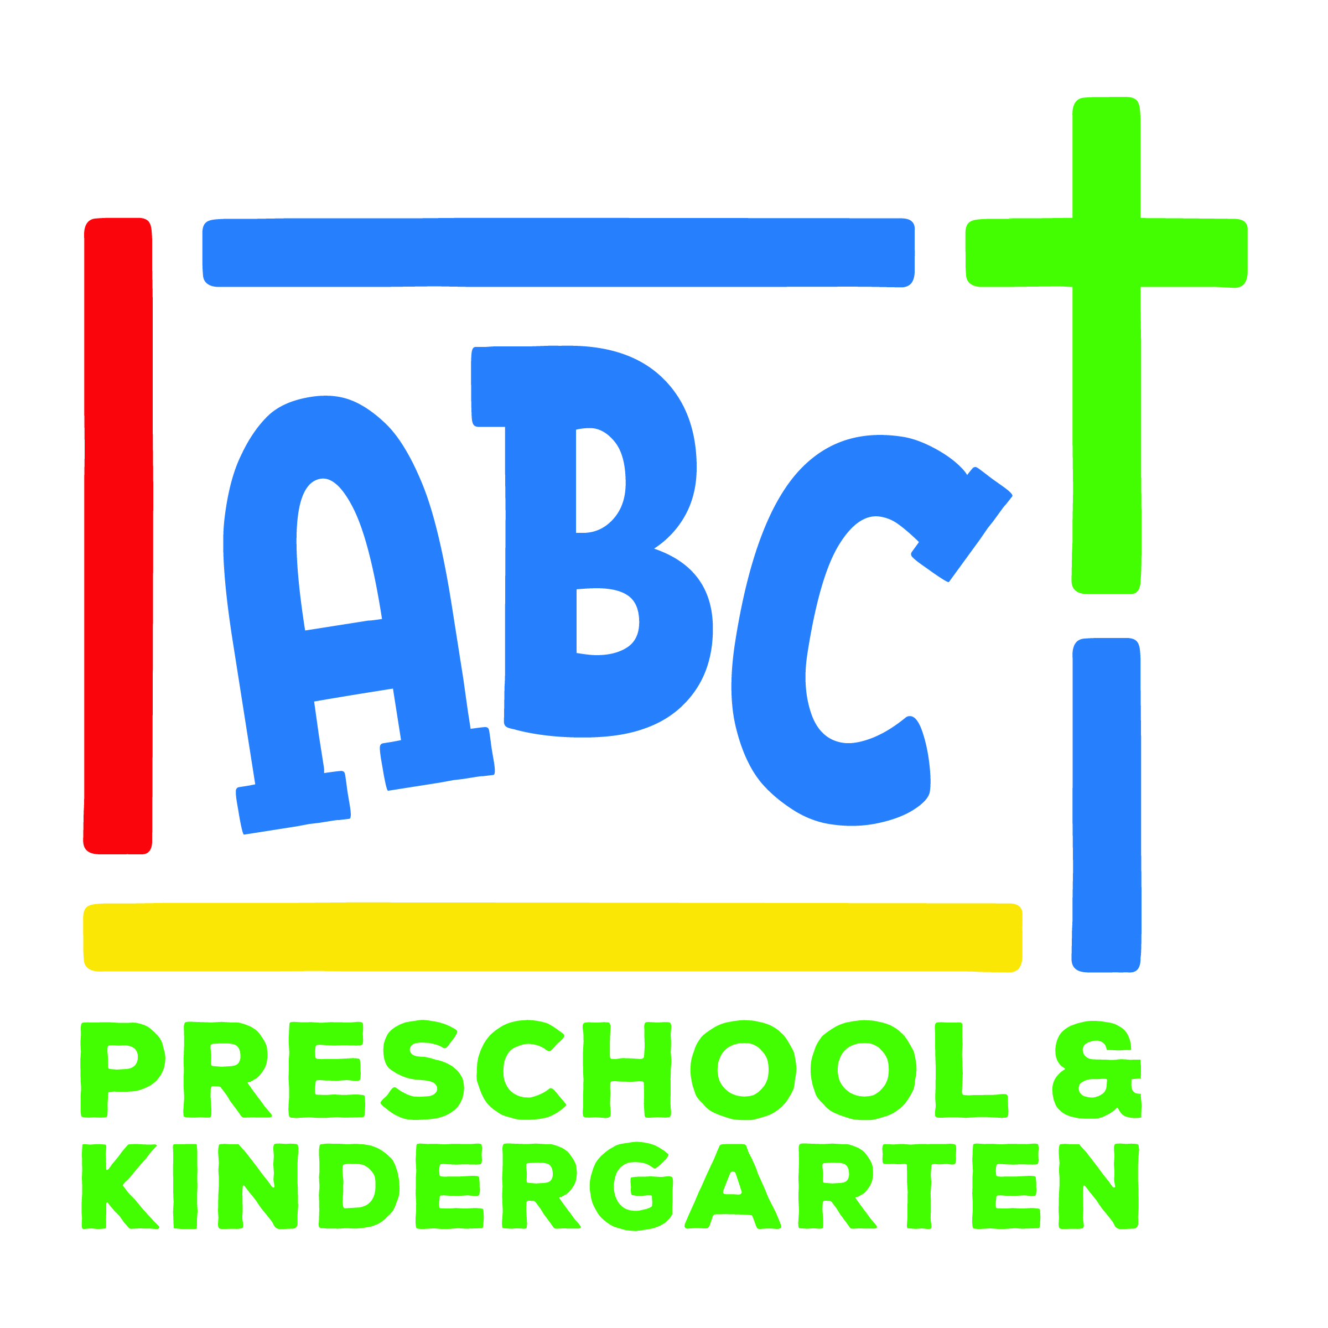

ABC Preschool and Kindergarten is growing! With growth comes the awesome opportunity to add to our team! We are a team of teachers who love to work together, pray together, laugh at the silly things kiddo’s do, come around each other on the hard days and most importantly are passionate about sharing the gospel with every family at ABC. We see our students reach milestones, have big wins, celebrate with families as we go through life together, and have a community with each other as a teaching team. We are looking to add to our team for the 2023 - 2024 school-year.

The nitty-gritty details:

What days do classes meet?
- Tuesdays and Thursdays (Preschool)
- Tuesdays, Wednesdays, and Thursdays (Kindergarten)

What time do classes meet?
- 9:30am - 2:30pm (teachers are here from 9 - 3)

Do I teach alone in the classroom or am I paired with a co-teacher?
- Each classroom has 2 co-teachers.

When does lesson planning happen?
- We have teacher workdays once a month on Mondays. These days offer you and your co-teacher time to collaborate on lesson plans for the upcoming month, plan activities, and freshen up the classroom with fun new toys!

